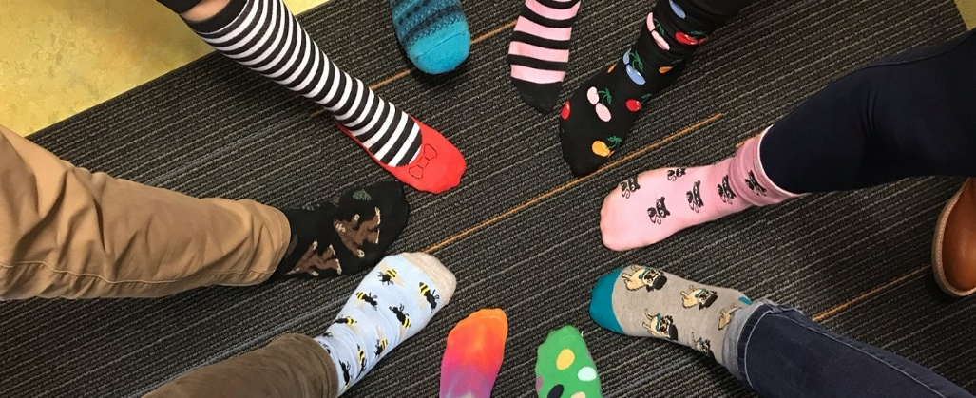

**ROCK YOUR SOCKS DAY**

**How many words can you make with the letters in:**

**ROCK YOUR SOCKS CRAZY SOCK DAY**

Make a list of words using the letters from the phrase above.

Send the list to Mrs. Miller at [cmiller@cbsd.org](mailto:cmiller@cbsd.org) if you are in grades 3, 4, 5 and 6.

Send your list to Mrs. Snively at [jsnively@cbsd.org](mailto:jsnively@cbsd.org) if you are in grades K, 1, and 2.

We will read all the words and share fun information and virtual wing tips.

Stay tuned to find out: who participated, who had the most words, who had the longest word, who had the shortest word and who had the most unique word.

Have fun!